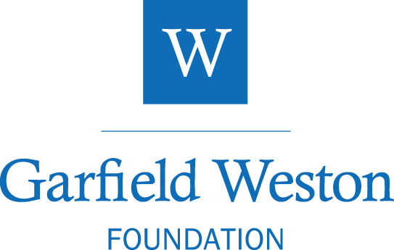

Pledge Release Request

We are delighted to hear that your organisation has successfully raised the total project request required and that the project is going ahead. In order for our Trustees to consider releasing their pledge, please complete this request form in full and submit it to the Foundation either via your online account, email it to admin@garfieldweston.org or send by post to our usual address.
Thank you.

Name of Organisation
FFP Reference (refer to your original pledge offer letter)
Title of project
Total cost of project
Scheduled start date of project/Capital work
Scheduled completion date
Your name
Position / Job title
I confirm that I am authorised to represent my organisation | Signature

Funding Breakdown

Please provide a summary of the project’s funding by source and amount. Please provide a total for your figures which should match that provided above (‘total cost of project’). Please continue on a separate sheet if necessary.

Funding Source | Amount in Pounds | Notes
TOTAL FUNDING SECURED | £

Please use this box to tell us anything else we need to know to help us review your pledge release.

